**TWO STAGE PIPELINE**

**EXP NO: 25**

**AIM:** To write a C program to implement two stage pipelining.

**PROCEDURE:**

Step1:Start

Step 2: Initialize the counter variable to 1.

Step 3:.Prompt the user to enter the first number (a).

Step 4:.Read the first number (a) from the user.

Step 5:Increment the counter by 1.

Step 6:Prompt the user to enter the second number (b).

Step 7:Read the second number (b) from the user.

Step 8:.Increment the counter by 1.

Step 9:Display the menu of operations: Addition, Subtraction, Multiplication, and Division.

Step 10:Prompt the user to select an operation (choice).

Step 11:Read the choice from the user.

Step 12:Use a switch statement to perform the operation based on the selected choice:

12.1For choice 1: Perform addition (res = a + b). Increment the counter by 1.

12.2For choice 2: Perform subtraction (res = a - b). Increment the counter by 1.

12.3. For choice 3: Perform multiplication (res = a * b). Increment the counter by 1.

12.4 For choice 4: Perform division (res = a / b). Increment the counter by 1.

12.5. For any other choice: Display "Wrong input".

Step 13: Display the value of the counter (the number of cycles taken).

Step 14:Prompt the user to enter the number of instructions (ins).

Step 15:Read the number of instructions (ins) from the user.

Step 16:Calculate the performance measure by dividing the number of instructions (ins) by the counter and store it in the performance measure variable.

Step 17:Display the performance measure

Step 18:End

**PROGRAM:**

**#**include<stdio.h> int main() { int counter =1,a,b,choice,res,ins; printf("Enter number 1:"); scanf("%d",&a); counter = counter+1; printf("Enter number 2:"); scanf("%d",&b); counter = counter +1; printf("1-Addition:\n2-Subtraction:\n3-Multiplication:\n4-Division:"); scanf("%d",&choice); switch(choice)

{ case 1: printf("Performing addition\n"); res = a+b; counter = counter+1; break; case 2: printf("Performing subtraction\n"); res = a-b; counter = counter+1;

break;

case 3: printf("Performing Multiplication\n"); res = a*b; counter = counter+1; break;

case 4: printf("Performing Division\n"); res = a/b; counter = counter+1; break; default: printf("Wrong input"); break;

} printf("The cycle value is:%d\n",counter); printf("Enter the number of instructions:"); scanf("%d",&ins); int performance_measure = ins/counter; printf("The performance measure is:%d\n",performance_measure); return 0;

}

**INPUT:**

**20**

**10**

**OUTPUT:**

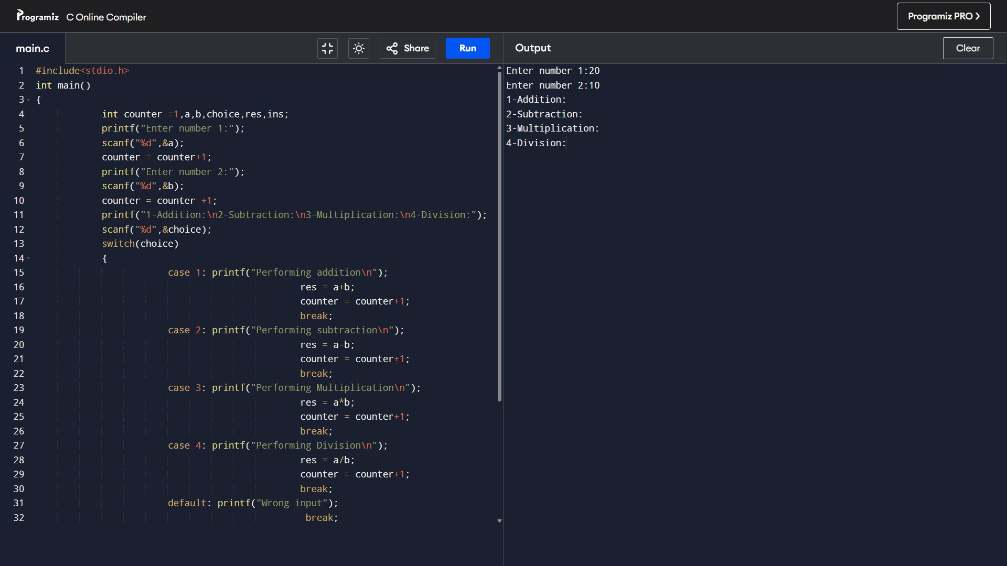

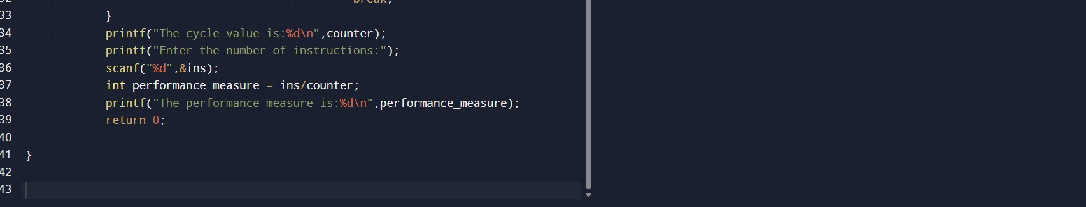

**RESULT:** Thus the program was executed successfully using DevC++.